Section A

For building a <<VIEW>>  LEVEL_DESIGNER MUST-HAVE <<VIEW>>

1. Display a Grid of varying Size

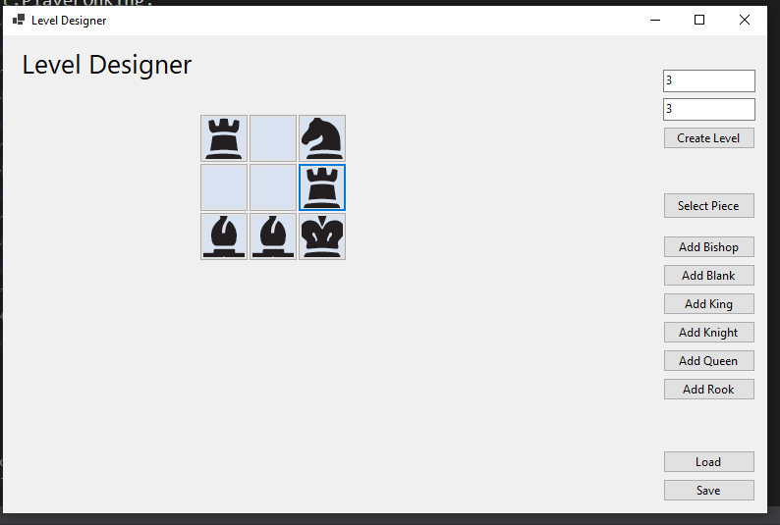

1. Allow Selection and Placement of a Piece  
   Text

   Description automatically generatedA picture containing text

   Description automatically generated
2. Replace Piece

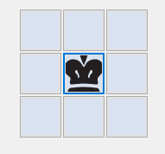

1. Save Works

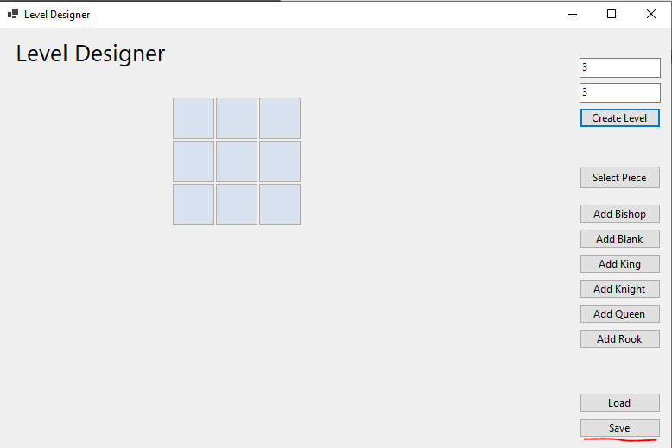

Saved as a 3x3

1. Load Works

Was unable to get loading working. I believe an issue with converting the Text to its respective image was happening

1. Useful Warnings – Error Handling

Set the game size to be a max 8x8 based on the width and height of the Form

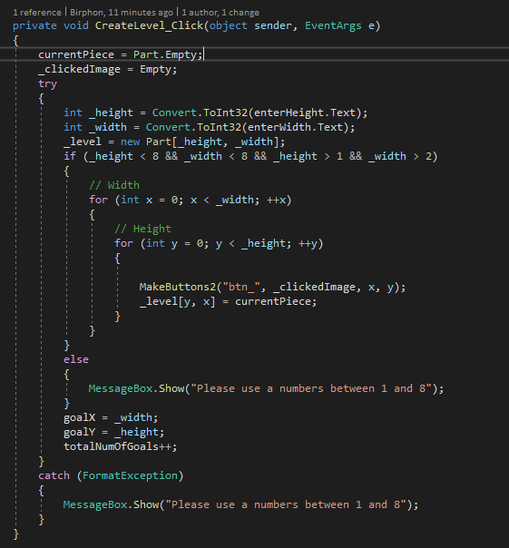

Refactoring Model Code

**Note: I was having issues with my Assignment 2 Code – some form of corruption issue? – I used Brock Winter’s Assignment 2 code for this thus the Form is also based on Brock’s Assignment 2 Code.**

Before – The pieces all got added the same way with just a different image.

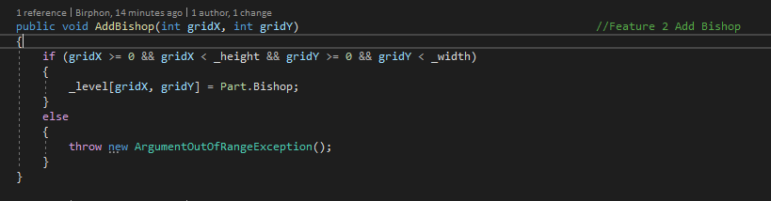

After: Removed the duplicate code between all the AddPiece methods and put it into its own method to be called

Code Reduction:

Before: 335 Lines of Code

After: 282 Lines of Code

Complete a Model

1. Find Player Location

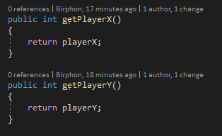

1. Get Move Count

Updates on Successful Move:

1. Validate Finished Game

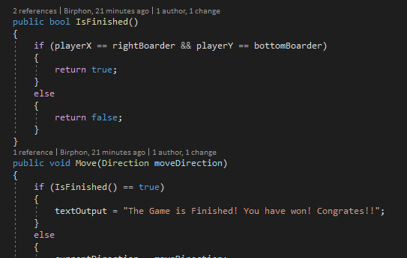

1. Move Rook

1. Move Knight

Movement is similar for all directions with just the number change in .Add() depending on which way the King is being moved

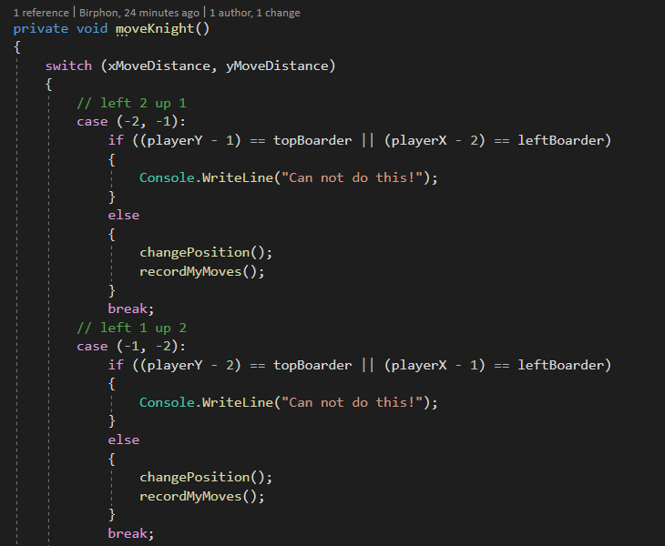

1. Move Bishop

1. Move King

Movement is similar for all directions with just the number change in .Add() depending on which way the King is being moved

1. Add Queen

1. Move Queen

1. Get Current Piece

1. Undo

1. Restart

1. Return Text Output

Since many of the pieces have the same movement sets (moveUp, moveDown) I used to make it so that each one had their own moveUp etc. Changed this to all be a callable function instead. Same applies to moveRecord(). The Knight and King where the only special bunch who couldn’t have this done because of their special movement